**Ag Food Science**

In this class you will be completing classwork and lab work with Mrs. Torgerson. In this class we will take a look at careers, food safety, kitchen fundamentals, fruits/vegetables/grains, proteins and more. You will complete hands-on lab work every week in order to get a full grasp of the course work as well as complete in class assignments.

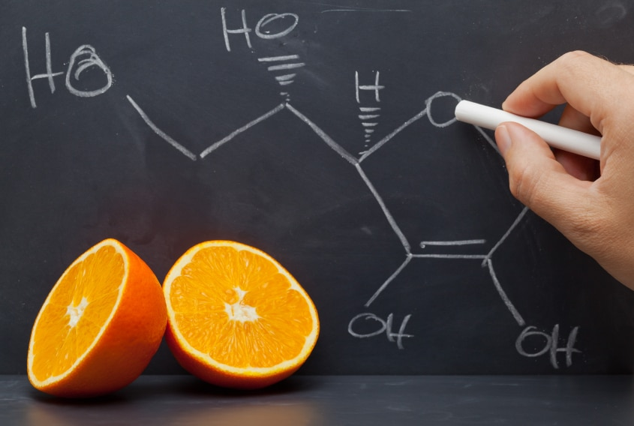

**Course Outline:**

* Careers in Food Science
* Safety and Sanitation
* Kitchen Fundamentals
* Food Preferences and the Senses
* Fruits/Vegetables
* Grains
* Eggs
* Proteins
  + Fats/Lipids
* Milk
* Sugar
* Informed Consumers
* Nutrition
* Dietary Choices & Influences
  + Food Allergies

**Grades will be based on:**

Assignments and Quizzes…………………………….70%

Attitude……………………………………………….15%

Daily Participation Points…………………………….15%

**Grading:**

95-100…A 90-94…..A-

87-89…..B+ 83-86…..B

80-82…..B- 77-79…..C+

73-76…..C 70-72…..C-

67-69…..D+ 63-66…..D

60-62…..D-

Below 60…F

**By taking this course, I will be able to:**

* Appreciate the role agriculture plays in my everyday life
* Safely cook and sanitize in a kitchen environment.
* Identify foodborne illnesses and causes.
* Demonstrate dining etiquette.
* Experiment with recipes to fit needs.
* Identify nutritious foods and make informed dietary choices.
* Explain kitchen fundamentals
* Calculate costs and nutritional values of recipes
* Identify food preservation practices
* Interpret food packaging marketing “key words”

**Miss Birons Classroom:**

1. Students will:
   1. **Respect:** Classmates, Teacher & Equipment
   2. **Think**: About what they say and treat others
   3. **Create:** An environment for success
   4. **Share:** Any success & any failures
   5. **Grow:** and learn from mistakes
2. Turn in all assignments on time
   1. Failure to do so and you will need a **homework slip** that will be sent home for a parents signature and 25% every day it is late.
   2. The late assignment must be turned in with the signed late slip.
   3. If a day of class is missed, you are responsible for seeing me about make up work.
3. Be on time to class
4. Be seated and ready to go when the bell rings
   1. Check the Agenda Board for the day’s activities
5. Do not leave class unless:
   1. There is permission from the teacher
   2. You signed out
   3. You have a hall pass
   4. If you leave the class without permission and disappear, it will result in either a before school or lunch detention.
6. Bottled Water is permitted in class (That is it, unless there are specific circumstances)
7. CELL PHONE POLICY:
   1. NO CELL PHONES! You are young adults. In this class I will not tell you to put your phone away. You can deal with the consequences of me taking it if I see it out!
8. Cheating/Bullying
   1. Cheating and Bullying are NOT TOLERATED in Miss Birons Classroom. If it is found that a student cheated on a test/quiz/assignment they will receive an automatic zero on that assignment.
9. Backpacks need to be kept out of walkways. Keep them under your desk if needed. As well, please push in your chairs at the end of class time.

Please read, sign, and return this signature page to the instructor to acknowledge that you understand the rules and expectations of this class.

Student Name_______________________________________

Student Signature____________________________________

Parent/Guardian Name_________________________________

Parent/Guardian Signature______________________________

Parent/Guardian Preferred Contact:

Please fill out the following contact information and check the box for your preferred contact method- this will be the first form of communication I will use to contact you about your student(s). If more than one contact should be included for each area, please add them.

𝥁 Email _________________________________(Contact Name_________________)

_________________________________(Contact Name_________________)

🗹 Phone _________________________________(Contact Name_________________)

_________________________________(Contact Name_________________)